You should be able to modify these 2 items in Word for your own usage:
Mr. Patrick; Devine
“American” Article 4 – Public Citizen Owner - ID

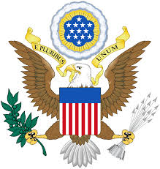
Rights of Life, Liberty and Pursuit of Happiness.
United States Republic Executive Owner:
Per the Republic Establishment Clause; as an American Republic
Guarantor of Protected SAFE PASSAGE and SAFE HARBOR.

18463 - 208th Avenue; Sigourney, Iowa Republic 52591-8236

“American” Article 4 - Public
Citizen Owner – Identification
.
United States Republic Citizen of Age:
Republic Birthing Date: 02 March 1949
Weight: 185 #Height: 6’ 0”
Hair color: Brown/grayEye color: Blue
Blood Type: 0+
Republic Citizen/Owner – Mr. Patrick; Devine
Left Index Right Index
|
|
|
|
|

Article 4 - Protected Rights and Powers.

Issued by the Living Republic Executive
of Age: July 28, 2016
Expiration:
Upon his Death

