WE THE PEOPLE:
an AMERICAN PUBLIC CITIZEN’S

PROOF OF PUBLIC Identification.
Constitution Article IV:
Section 2. The Citizens of each State SHALL BE ENTITLED to all Privileges and Immunities of Citizens in the several States.
An American Public Citizen’s Rights and Freedoms; as a Privilege is a Right to Contract using an implied SURETY (fictional Slave) person and an Immunity means you are NOT to be FORCED into a Contract.
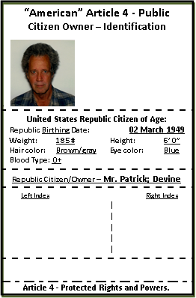
Mr. Patrick; Devine
“American” Article 4 - Public Citizen Owner – ID
18463 - 208th Avenue; Sigourney, Iowa Republic 52591-8236

Rights of Life, Liberty and Pursuit of Happiness.
United States Republic Executive Owner:
Per the Republic Establishment Clause; as an American Republic
Guarantor of Protected SAFE PASSAGE and SAFE HARBOR.
Issued by the Public American Citizen on: November 03, 2016
Expiration:
Upon his Death

Date: ___________________
Signed and Sealed By: ____________________________________
Mr. Patrick; Devine; Authorizing Signature
Individual Public Banker: per EIN # xx-xxxxxxx
STATE OF IOWA
COUNTY OF KEOKUK
On this day Mr. Patrick; Devine; personally appeared before me, known to me or proven to be the person described above and who executed this instrument and acknowledged that he signed the same as his voluntary act and deed, for the uses and purposes therein mentioned.
Witness my hand and official seal hereto affixed on this day of _________________, 20___.
Notary's Title of Office: __________________________. Notary's Public Signature: ___________________________
My commission expires _______________. Under seal

