Above This Line Reserved For Official Use Only
NOTICE of Cause of Action for the Record by Patrick Devine:
My American Admiralty Alien Living Vessel Christening Certificate
and Perfected Alien Claims.
ADMIRALTY LIEN: A lien on a Vessel enforceable by a suit in rem in Admiralty for repairs, supplies, towage, use of dry dock or marine railway, or other Necessaries furnished to the Vessel. 2 Am J2d Adm § 124.
Based upon the American Admiralty and Roman Christening Laws, this Christening Baptism Certificate is my “Patrick Devine” American Admiralty perfected Alien Title, as my Right of TITLE to CLAIM my American Vessel Constitutionally protected Rights and Powers and my Inheritance and Entitlements claims from the American Constitutional Admiralty Treasury Trust and per my Notation Conformation name of Patrick ‘Paul’ Devine to claim my Church of Rome Treasury Trust inheritance.
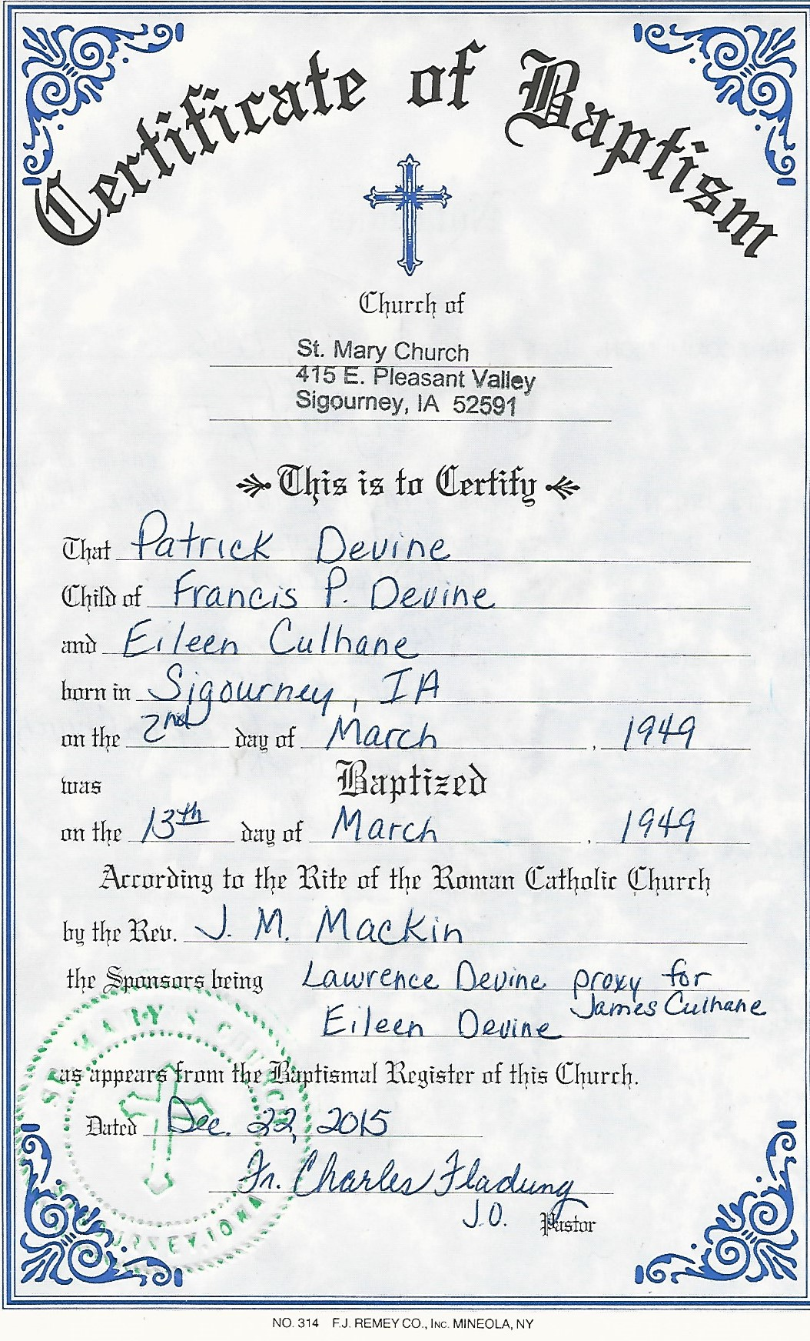
My PERFECTED ADMIRALTY ALIEN CLAIMS: as an Ouster Le Main, as I am of Age to lawfully ouster all Alien Property Custodians.

Date: __________________
By the Living American Vessel Alien Holder in Due Course:
___________________________________
Patrick: of the estate of Devine
(Left index) (Right index)

(Signed and Sealed)

Safe Harbor Address:
c/o: 18463 -208th Avenue
Sigourney, Iowa 52591-8236
Phone (641) 541-0035
Patrick: of the family Devine
(Signed and Sealed with my American Vessel’s Boundary Markings) (Left index) (Right index)

Patrick: of the family Devine
(Signed and Sealed with my American Vessel’s Boundary Markings) (Left index) (Right index)
c/o: 18463 -208th Avenue, Sigourney, Iowa 52591-8236
Phone (641) 541-0035

STATE OF IOWA
COUNTY OF KEOKUK
On this day Patrick Devine; personally appeared before me, known to me or proven to be the person described above and who executed this instrument and acknowledged that he signed the same as his voluntary act and deed, for the uses and purposes therein mentioned.
Witness my hand and official seal hereto affixed on this day of _________________, 20___.
Notary's Title of Office: _____________________________. Notary's Public Signature: ___________________________
My commission expires _______________. Under seal

