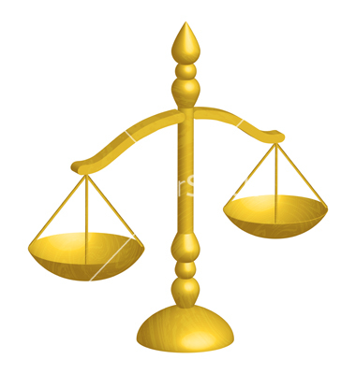  NATIVE AMERICAN LAW AND JUSTICE CENTER ©  Monetize Your Certificate of Live Birth.  It's worth millions!  Your Certificate of Live Birth (CoLB) or Birth Certificate (BC) is a security worth many millions. Most Certificates, but not all, are printed on bank note paper just like securities.  The Native American Law and Justice Center© has arranged with an overseas bank which recognizes and accepts the worth and value of your CoLB to place it into a trading program called a Private Placement Program (PPP) which will provide you with:  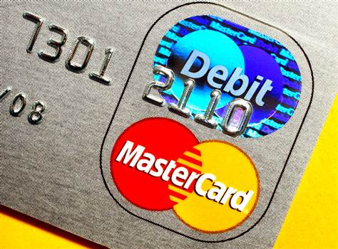  • A constant cash flow for 50 years is practically and verifiably attainable.  • A trust will be set up for you.  • A debit card will be issued to your trust name, which you can use to withdraw funds, pay bills, make purchases, etc.  • For larger purchases you arrange with the bank to send the funds directly to the seller.  • You may enter birth and death certificates of family and relations.  •email knowledgevillage80a@gmail.com for “FULL TRIBAL BENEFITS”, and for other private and confidential requests, questions and concerns.  (see over for further details)  ---------------------------------------------------------------------------------  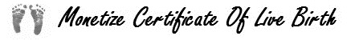  • For complete details visit the website http://MonetizeCoLB.ORG  • For general questions and to discuss this further with others, join  Facebook: https://www.facebook.com/groups/monetizecolb/ |  | To receive these funds, for a modest fee of $500 and an administration fee of $50, we can provide you with the knowledge to learn about and complete the process.  When we reach our goal of 20,000 certificates, we will use your fee to purchase an International Bill of Exchange (IBoE), which will trigger the process to start a PPP program.  Most CoLBs throughout the world are securities of great value. People from Germany, China, France, Argentina, Mexico, Malaysia, Australia, Hungary and New Zealand have already joined this program. Any evidence of birth from any country will work as long as we have an English Language translation.  Open to everyone regardless of age. Minors will need parental affidavits and signatures. Uncertified COPIES – with three witnesses’ names, telephone numbers, email addresses, mailing addresses, and signatures NOTARIZED – of birth certificates, death certificates, Baptismal records, naturalization certificates, midwife’s affidavits, or church records are the usual evidence and proof required.  To complete the program you need to:  • Go to http://www.MonetizeCoLB.ORG/overview.php for complete details.  • Download the Memorandum of Understanding (MoU). It is your  contract with the Native American Law and Justice Center. Print,  read, fill it in, and sign it before a witness who must also sign.  • Locate your evidences of birth.  • Send in your payments and documents.  ------------------------------------------------------------------------------  • For general questions and to discuss this further with others join  Facebook: https://www.facebook.com/groups/monetizecolb/

