My American Admiralty Vessel Baptismal Blessing
and Foreign Admiralty Affidavit:
“Vessel Name”, Marked and Sealed; as my Written “Estoppel of Piracy” in LAW.
By my American Admiralty Authority per an Ecclesiastical Court; I was blessed with the American Christian Name Vessel of Patrick Devine; please refer to the below copy of my Ecclesiastical Court “Baptism” (Christening) Vessel Certificate. This Ecclesiastical Court Recorded Certificate also stands as my Ecclesiastical Court - American Copyrighted Christian Name, Vessel and all Cargo Attachments in the Laws of America Admiralty Jurisdiction and it is my Estoppel of Piracy against all Foreign Governmental or Commercial Fraudulent Banking Acts “For Unjust Profit”; per their US Governmental License granted by “USC Title 46, Ch. 573”. All “Acts of US Licensed Piracy” were to be terminated upon my American Christian Name, my American Admiralty vessels and all of my vessel attachments by my Ecclesiastical Court “Confirmation” to be able to issue Authoritative Orders, including Fraudulent Piracy “For Unjust Profit and Benefits” Contract Terminations, as of May 15, 1961 or at my Vessel’s age of 25.
Therefore, any Foreign “Act of Piracy” is a Criminal Copyright Infringement against my Ecclesiastical Court - American Copyrighted Christian Name, Vessel and all my Cargo Attachments; when performed by any Foreign Governmental or Commercial Banking Acts or Contracts under Fraudulent Concealments or Unauthorized and Fraudulent Usage of my American Vessel’s Name or my Vessel’s Cargo by their usage of an Un-Christened and Foreign SS “MORTMAIN NAMED” Vessel “For Their Unjust PROFITS and BENEFITS”.

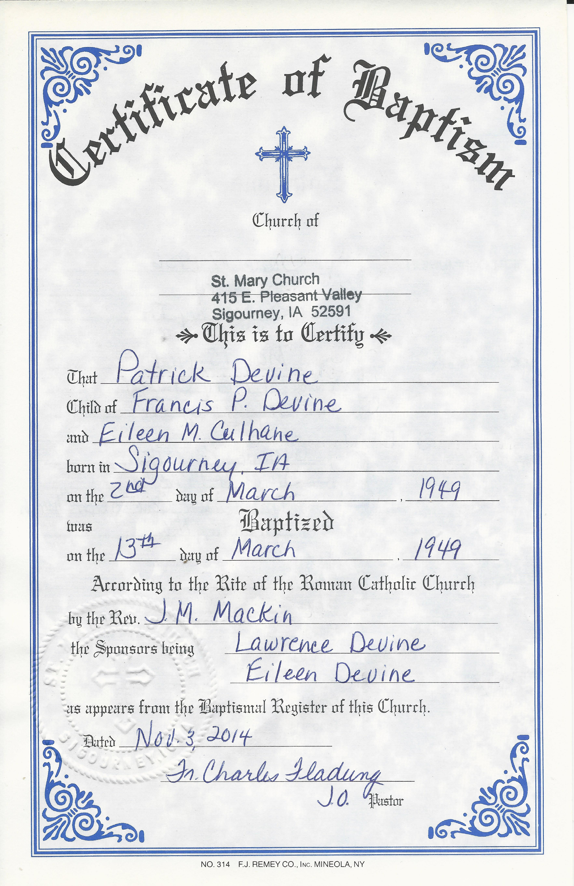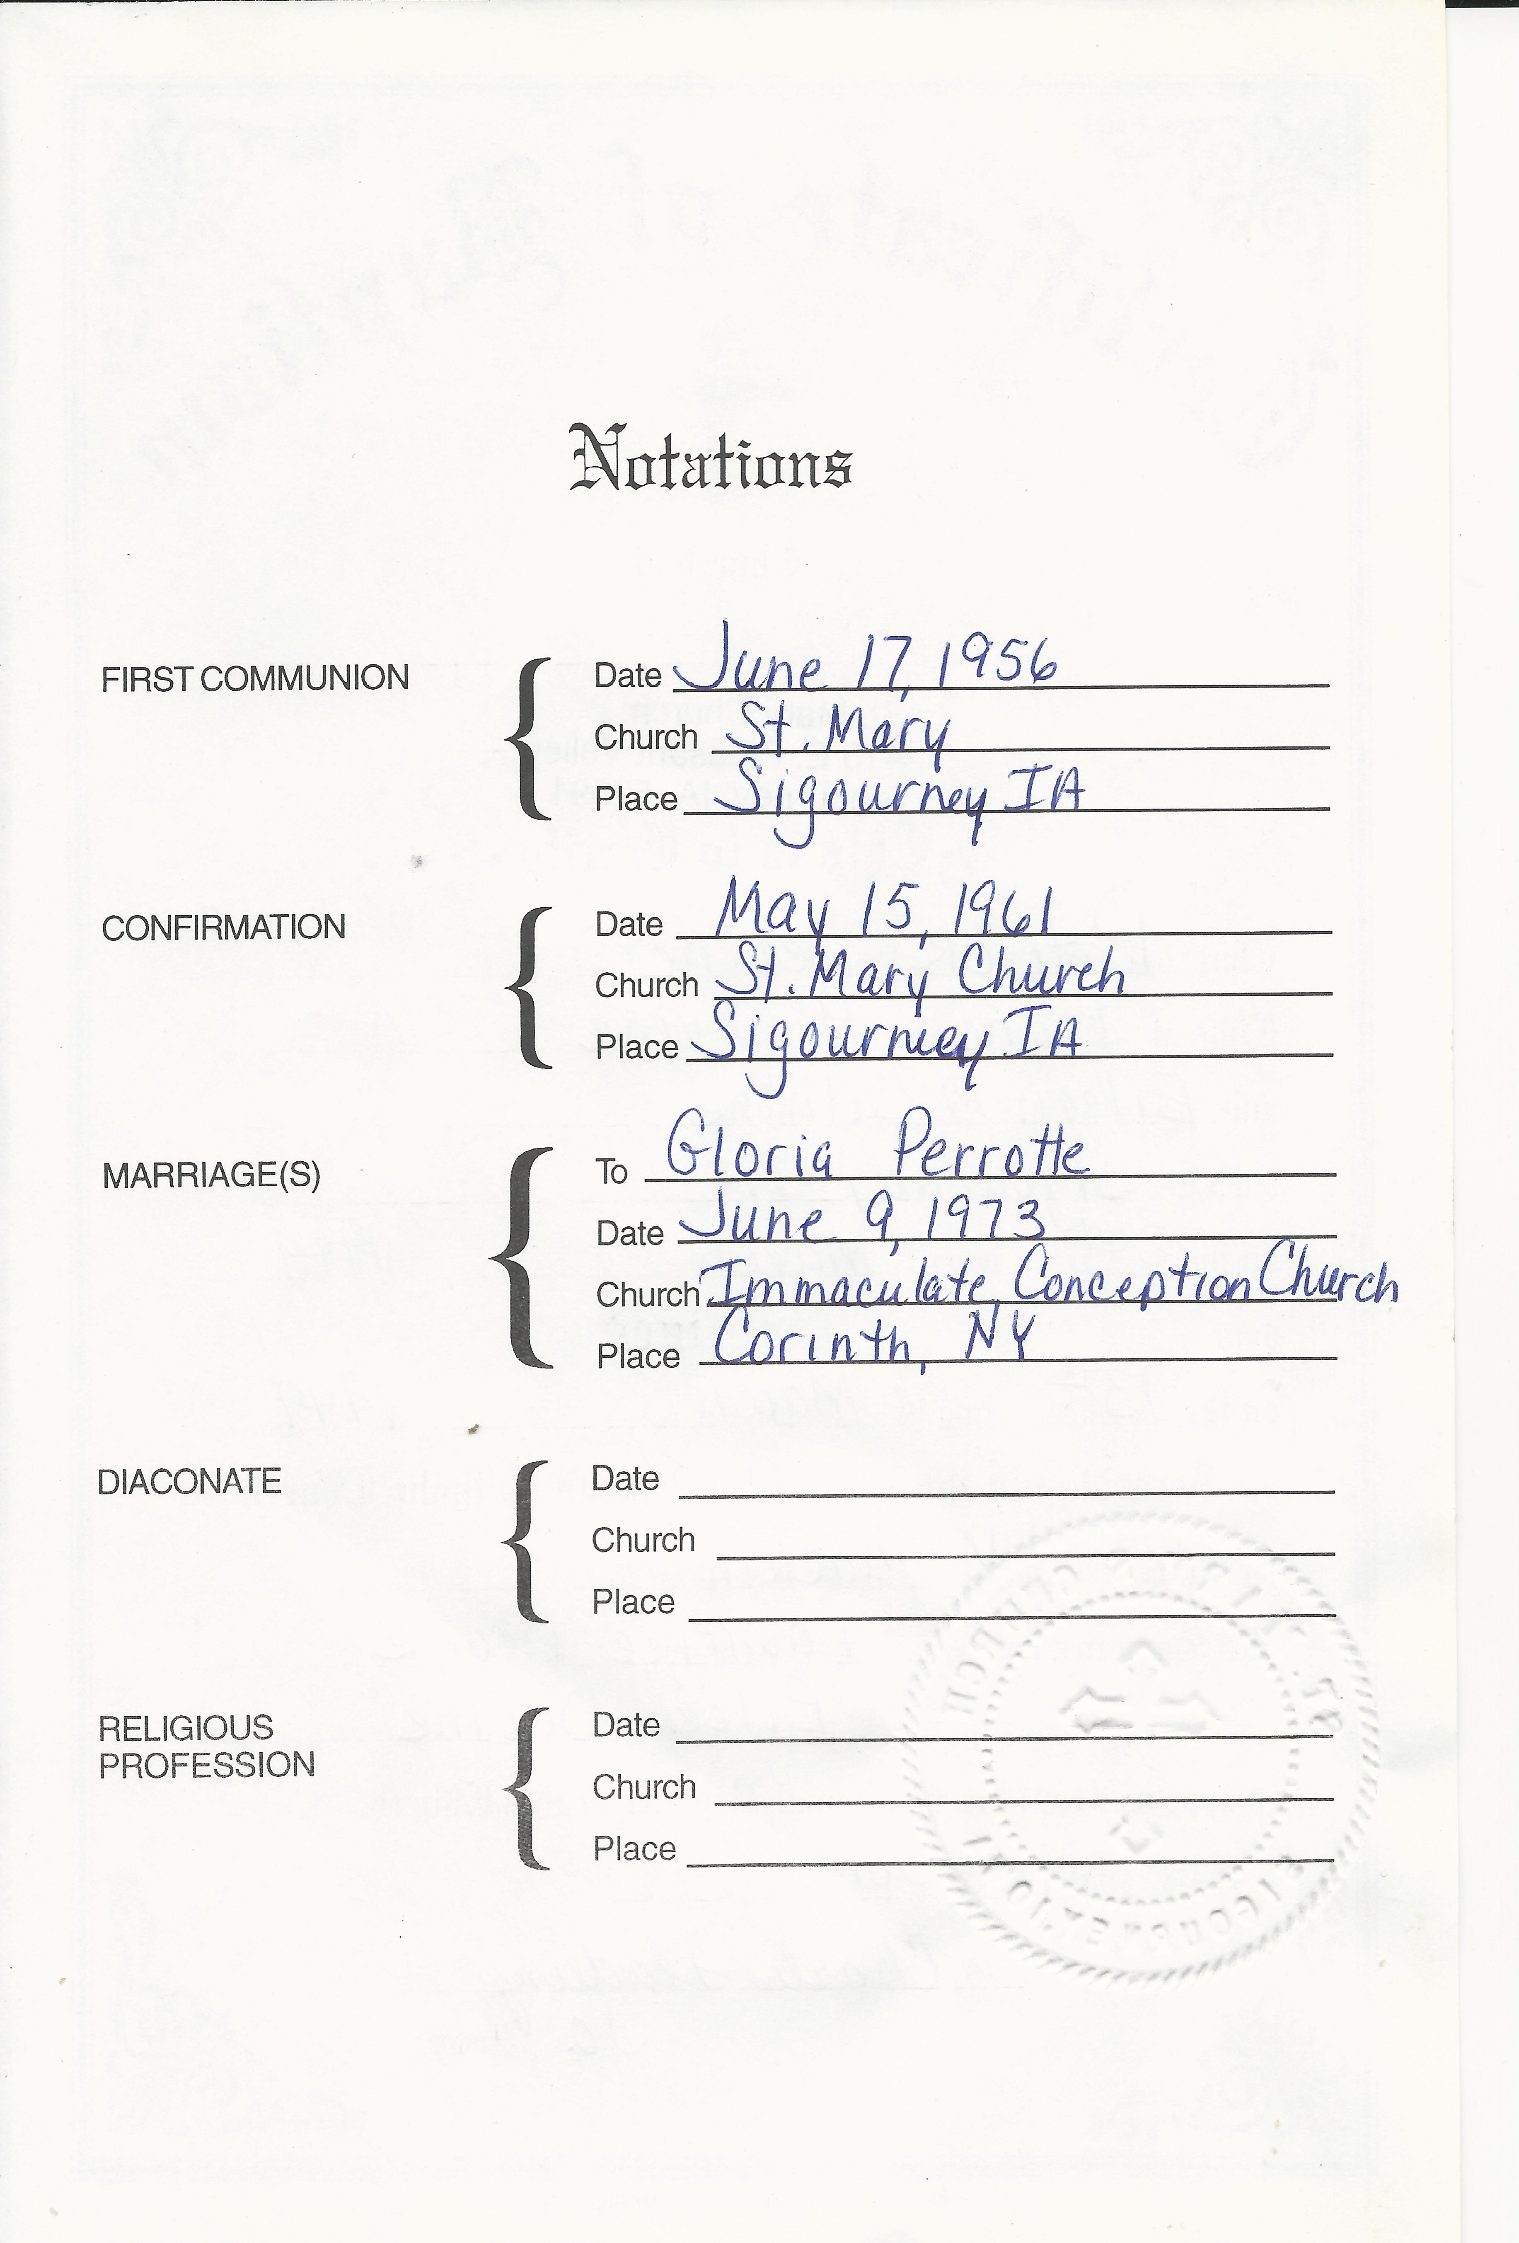

Thereupon, by my Signing and Sealing this document, I attest to all of the previous statements as being the Truth and Facts in Law. I therefore stand in Admiralty and Order all “Act of Piracy” Contracts and Fraudulent Criminal Charges against this American Admiralty Vessel Owner are to be Terminated, Stricken from the Records and Restitution made to this Vessel Owner; as they were performed in Fraud, a Piracy “For Unjust Profits”. There is no time limitations of restitution for all banking Acts of Piracy or Fraud all the way back the Vessel’s Christening and this action is also supported by the “Baby Act”.
FRAUD: Deceit, Trickery, sharp practice, or breach of confidence, perpetrated FOR PROFIT or to gain some unfair or dishonest advantage.
PIRACY: (Brit) Robbery on the seas [this includes the commercial banking seas] within Admiralty Jurisdiction.
ROBBERY: law. the Felonious Taking of the property of another from his or her person or in his or her immediate presence, against his or her will, by violence OR INTIMIDATION.
My “FBI – WARNING”: The Federal Law provides Severe Civil and Criminal Penalties for the Unauthorized Reproduction, Distribution or Exhibition of my Ecclesiastical Court – American Copyrighted “Christian NAME or VESSEL”. Criminal Copyright Infringement is to be investigated by the FBI and the Federal Banking Inspector Generals for Banking Fraud and Piracy, which may constitute a Felony with a maximum penalty of up to 5 years in prison and/or a $250.000 Fine.
Date of Execution: ______________.
By the Vessel Owner - Patrick: of the family Devine ____________________________
(Vessel’s Boundary Markings) (Left index) (Right index)

OFFICIAL NOTARY PUBLIC for:
Iowa State;
Keokuk County.
As this document is noted to be a Foreign Affidavit and it is required to be Signed and Sworn under Oath before Government Notary. So on this the day of , ; Patrick Devine, personally known to me or proven to me by a valid Iowa State photo ID # _________________; to be of Age and appears to be of a sound mind, did sign and swore under oath that this Affidavit is his documented truths and beliefs. Therefore, as a Duly Commissioned and Authorized Iowa Official Notary by the Constitutional Statutes of Iowa to administer oaths, I do Attest to and Certify the Authority of Patrick Devine; thereby making this Affidavit valid per the Law, in order for it to be presented into and required to be accepted into any United States - Foreign State’s Jurisdiction.
Signature: ______________________________ Title: _____________________________________
Printed Name: ______________________________ My commission expires: ________________
(under my Notary Seal)

